1. **Install nginx and run nginx on port number 81.**

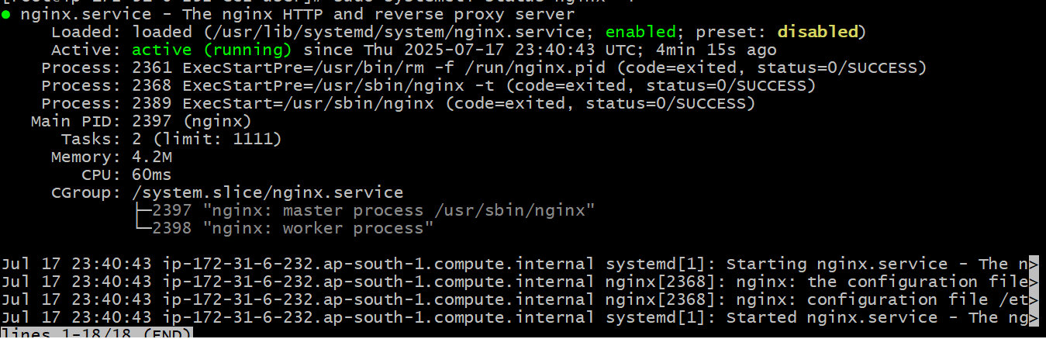

1. **Deploy a sample index.html file on nginx.**

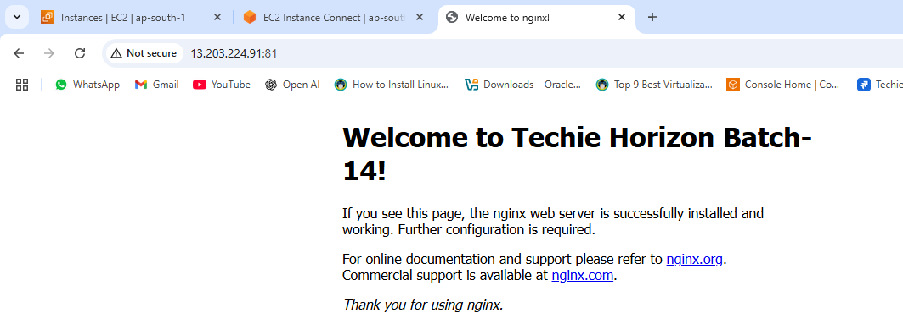

1. **Install Apache and run Apache on port number 82**

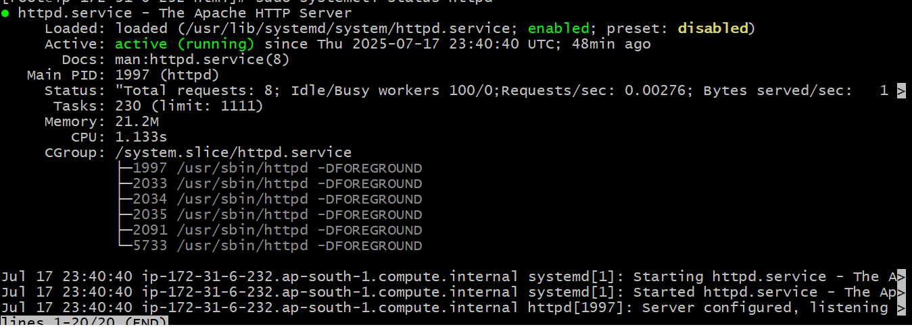

1. **Deploy a sample index.html file on Apache.**

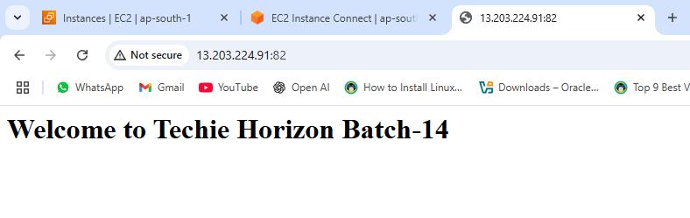

1. **Install Apache tomcat on port number 8082**

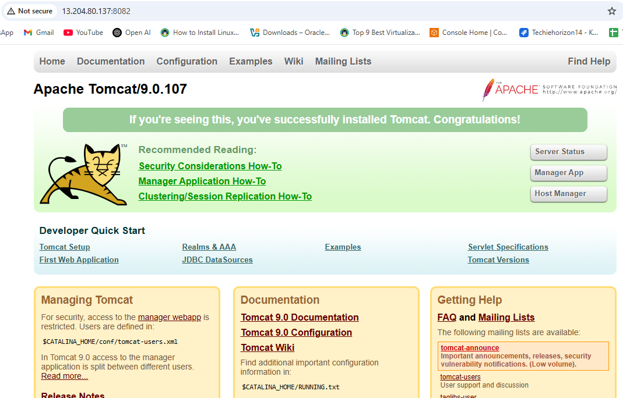

1. **Deploy a sample app on web apps**

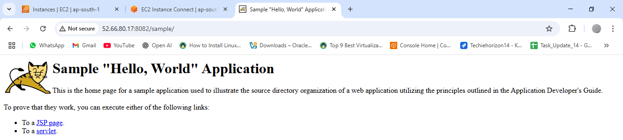

1. **Create a tomcat.Service file for tomcat.**

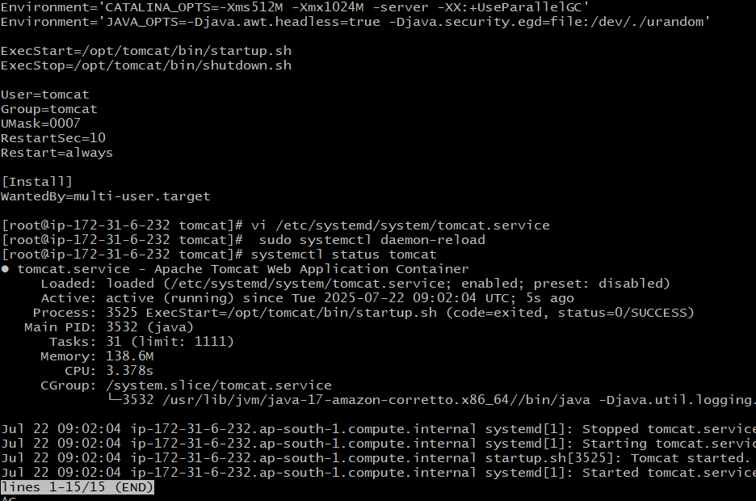

1. **Configure HA Proxy server**

